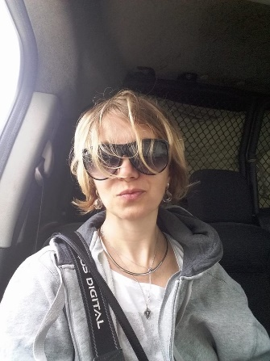
Personal information:
Name: Svitlana Lishchynska
Date of birth: October 15, 1970
Place of birth: Mariupol, Ukraine.
Tel .: +38 0935520703
E-mail: documenttv@gmail.com
https://www.facebook.com/svetlana.lischynska
Education: Priazovskyi State Technical University. Vitaly Mansky's workshop, Alexander Mitta's courses, Terrarium Script Intensive.
Qualifications: director, scriptwriter.

Work experience:

2021
Screenplay of the feature film Goodbye, Fashion! currently passed to the second stage of the competition from the Gothenburg Foundation.

Participation in pitching Dziga MB with the script of the feature film Goodbye, Fashion!

Treasures of Verona documentary - director

The premiere took place as part of the Ukrainian Film Festival in Rome.
Catalog of the festival Visions du Reel.

2017
Invisible Battalion documentary – director of two novels

1+1 TV Channel, director
Community for a Million social reality show

2015-2017
1 + 1 TV Channel, director
Wife Swap reality show, Blind Wedding reality show

2014
EuroMaidan SOS. The Right to Dignity documentary film - director, scriptwriter

2010-2014
Novy TV Channel, - production director

Sing, if You Can, Light Heads, Battle Of The Sexes tv shows
Parents and Children reality show

2008-2010
TV project Fashion Week with Daria Shapovalova – director

2008
ICTV TV Channel, director
Marital Games reality show

2003-2008
Inter TV Channel, director
Miss Ukraine Universe 2006, 2007, 2008, Vienna Ball, Your Movie
Days of Ukraine on the Cote d'Azur, Chance.model.ua

2000-2003
STB TV Channel, director
Sill the puppet show
Day.Ok

Spesial scills: screenwriter, editor, dop.

