Directing style
~「Fear not in the dark, go deep into the subconscious,
and find the connection deep in the soul」

Ellan wang

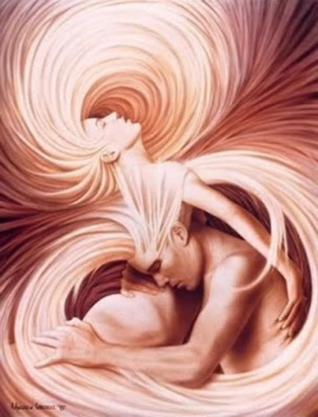

All the way from philosophy and psychology to the Film Institute of National Taiwan University of Arts, it is a journey of self and spiritual exploration one after another. The directors I love deeply: Fellini and Bergman. Movies: "Sweet Time" and "Mask" all express the darkness of the heart.
The master's thesis is to use storytelling to describe the process of becoming a counselor. Nearly 20 years of counseling work has mainly dealt with teenagers who are broken-hearted, melancholy, refusal to study and family problems. I believe that through my specialization in psychological work, I can have a deeper and more detailed grasp of the characters in the plot.
In the past few years of studying at the Film Institute, I have experienced my own midlife crisis. At the moment when I was in a spiritual crisis, I accidentally came into contact with the field of "painting art therapy", which was also one of the psychotherapy methods developed by Jung in his later years.
During the two-day visual painting process, I directly faced my own inner dilemma and melancholy. I was soaked in the dark blue melancholic sea, and I couldn't escape, and my emotions almost broke the bank. Then, from the deep sea, I slowly discovered some creatures and plants in the sea, and the picture began to change. After that, I found a rock in the sea. In the process of painting, the rock gradually changed. Finally, the huge rock turned into Mount Fuji on the bottom of the sea, rising from the deep blue sea. In two days, I experienced: self-doubt, emotional breakdown, self-acceptance, and finally, I drew Mount Fuji which represents the symbol of rebirth. Looking at my paintings, the series of changes that have taken place, and an incredible spiritual journey, I was deeply touched and inspired. Believe that you have the power to get out of the predicament of life. For this reason, the script "Picture in Dream" was created.

"Without shadow, there is no light, without imperfection, there is no spiritual integrity." ~ Carl Gustav Jung

When I broke the connection with the inner self, Jung said: Dreams are the window of the subconscious. Through dreams, you can reconnect with yourself again.
My experience in painting art therapy has become the creative prototype for the story of "Dream Painting". What the story wants to convey is that as long as you accept the fragility of your heart and are not afraid of the darkness, you can find your connection with yourself, reintegrate yourself, and get the joy of rebirth.
The first half of the "Dream Picture" refers to the blue emotional appeal of the movie, and uses a large number of "shallow depth of field" and "close-up" visual features to show the character's mental state, locking the focus on the character's "emotion" and depicting The middle-aged dilemma of the protagonist. The background music, using Debussy's opera: Lu Shaka, implies that the heroine is trapped in emotional injury.
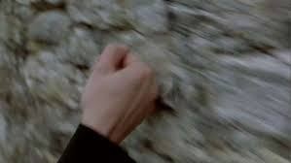
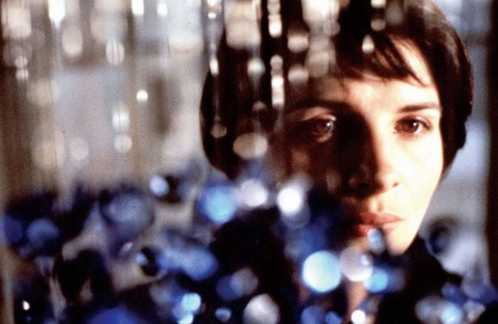

In the second half, a magical and realistic style will be added. Dynamically transform the protagonist's giant painting, let the protagonist experience the painting dynamics in a more three-dimensional and stylized way, such as building the inner spiritual world of the protagonist, so that the audience can personally enter the inner world of the protagonist. I also experienced a journey of art therapy like intuitive painting.
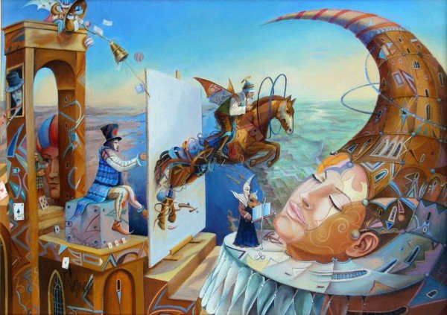

Just like the movie (1952) Ikiru , the protagonist who is looking for the answer to life. Sudden accidents give the protagonist a chance to find the key to solve the plight of life. The young girl in the story, through rebellion and collision, forced the heroine whose life has been rigid and trapped, to face her own crisis and get out of the predicament. The two injured women danced together in the moonlight, regained their connection with themselves and healed each other.

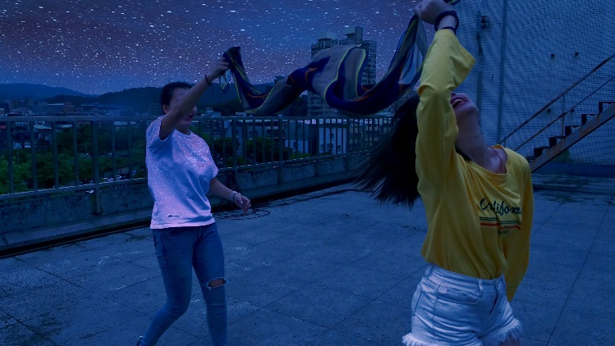

- Introduction of Director's film

- Scars/ 2017年
The idea of ​​"Scar" is because the director's own family has suffered from depression for many years and attempted suicide by jumping off the building three years ago. In the short film, I want to describe the mental stress and inner fear faced by family members who are caring for melancholy and suicidal experiences.

In the film, the "dream catcher" is used to indicate that being with a depressed family member is a long-term nightmare for caregivers.

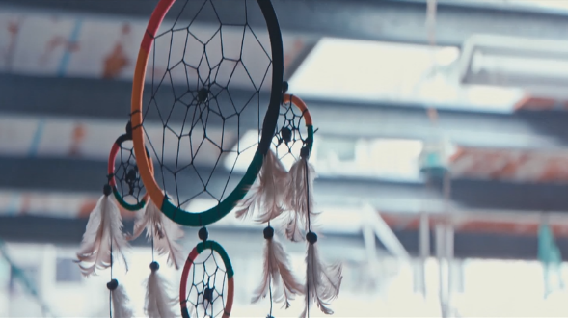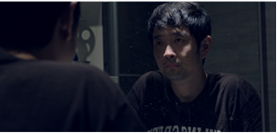

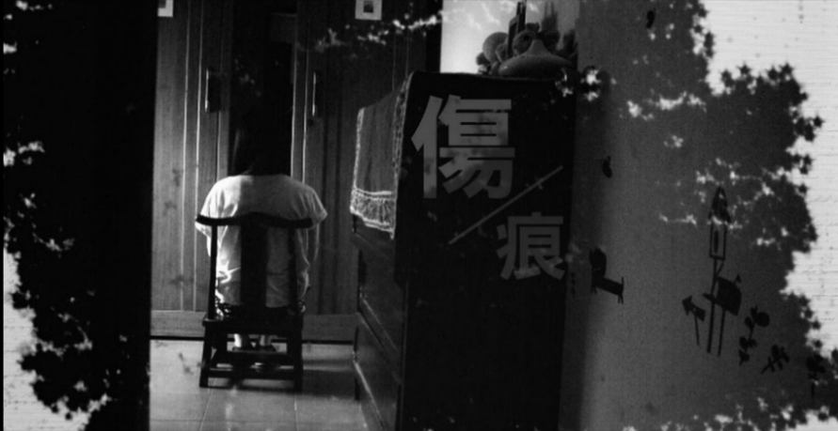

「Scars」 QRcode。



- Women’s talk / 2017年
The documentary of " Women’s talk " has realized my long-standing idea of ​​wanting to shoot unique stories that belong to women. Recalling the first time, I took a camera to tell a story. The protagonist of the filming was an illiterate grandmother. Because the film received a small reward, it opened the way for me to learn to become a director.
" Women’s talk " The heroine of the documentary: Xiao Hua, is my good friend. I admire her, a bold modern woman who wants to have a baby but does not want to get married. In society 30 years ago, it was not easy. Regardless of family opposition, Xiao Hua gave birth to children out of wedlock. As a result, her eldest son's legal guardianship was still taken away by her ex-husband. Ten years later, she insisted on giving birth out of wedlock again. Finally, she was accepted and supported by her family.
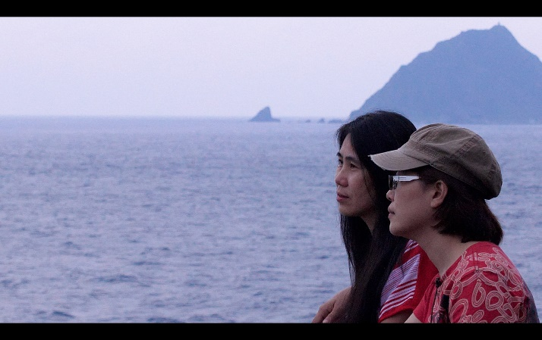
" Women’s talk " In the documentary, I boldly tried to talk with my friends in a defensive situation. This is a very private and unique way of dialogue between women.

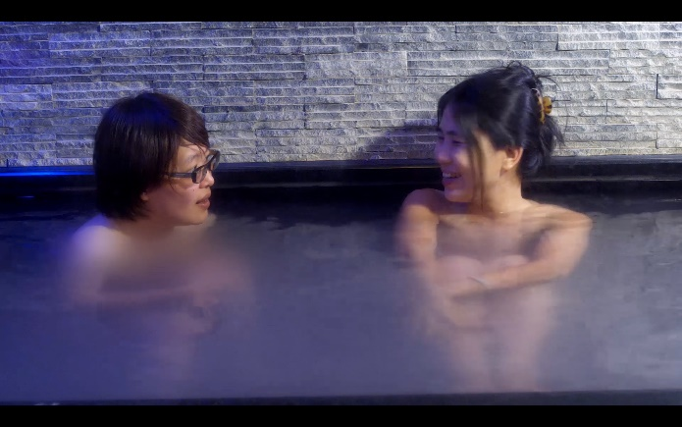

In the film, I also quoted Ruan Lingyu as a metaphor for Xiao Hua. Women have to do their own process and experience the hardship of being discussed and criticized by others. After trying this documentary, it also made me more sure. I want to shoot: life stories of women's unique experiences.

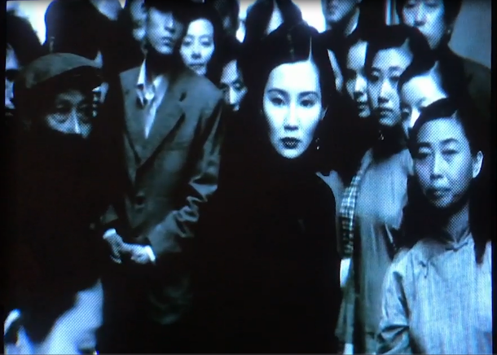

「Women’s talk」 Qrcode 。



