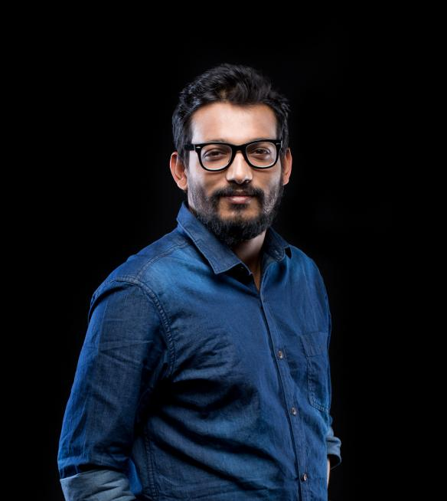

Prataya Saha - Filmmaker, Creative Director, Red Polka Productions

Films:

Prataya Saha is an independent filmmaker, Tedx performer, theatre director & photographer based out of Bangalore, India.

Prataya's directorial debut was Anna's Weekend in 2016 which got selected in festivals in US and China. Thirst, his second film, was selected as official entry in the 14th International Independent film festival, Dhaka; one of the oldest running film festivals in Asia. He is now 8 short films old with his films selected in 60+ film festivals around the world, winning over 14 awards, including the prestigious Oaxaca Film Fest, Woodpecker International Film Festival, Cardiff International Film Festival, Oscar Qualifying festivals like Bengaluru International Film Festival, etc.

Most of his films revolve around issues faced by women or have a strong female protagonist aided by a crew where women hold important positions like writer, asst. director, cinematographer or producer.

Films streaming on OTT:

3 films on Disney+Hotstar

4 films on Hungama Play

4 films on Mx Player

1 film on Starzplay, Middle East

A record three of his films have been accepted in Viddsee.com, South East Asia’s largest online independent film curators.

Links on films on Disney+Hotstar:

The Good Wife:

https://www.hotstar.com/in/movies/the-good-wife/1835045497/watch

Synopsis:

The time was December, 1992 -a time of great upheaval, tension, sorrow and uncertainty in the old and ageing city of Kolkata (then Calcutta), eastern India.

Inspired by stories that have cropped up during our childhood & produced and part-written by two female artists, 'The Good Wife', is an award winning short film, that revolves around the highs, lows, joys, defeat & triumphs of a woman in the course of a single day; a woman whose character we have not given a name. The character is a woman whom we have not named because she is an epitome of an ancient and seemingly eternal typecast, ‘The Good Wife’ and thus can be anyone.

The story of this film takes place 27 yrs back in the city of Kolkata in 1992 during the period of great uncertainty. This is a story of a simple woman who travels through a curfew lit city to get her husband’s favourite food to keep him happy in all the possible ways as according to the conditioning of being a good wife.
The story traces the joys and sorrows and triumphs and disappointments through the happening of a single day in the life of one such housewife, thus through her journey we have explored the immense strength inside a woman termed as good wife, maybe not the strengths atypical with chest thumping toxic masculinity but a more subtler inner feminine strength

We hope our film, ‘The Good Wife,’ is finally able to demystify the plight of this large section of society that exists even today and finally bring forth to the world, their voices, which till now have been echoing in the inside chambers of their hearts.

Slapped:

https://www.hotstar.com/in/movies/slapped/1835054949/watch

Synopsis:

'Slapped' is a story of a physically abused young woman in an incompatible arranged marriage. A story that resonates with the plight of thousands of women all over the world but few still come forward due to stigma, hurt and shame.
But is that all to it?
'Slapped' takes us through a dialogue between the oppressor and the oppressed but also brings up a lot of other questions in the end.

The film has been a complete virtual collaboration between various places in the states of Karnataka and Kerala in India and Singapore.
Collaboration on Acting, Direction, Colour grading and Cinematography for the film has happened over Zoom calling.

The Newly Weds:

https://www.hotstar.com/in/movies/the-newly-weds/1808015075/watch

Synopsis:

The Newly Weds is a glimpse into the life of an urban, tech savvy, newly married couple living in the digital technology age in an urban city in India.
They love each other dearly, miss each other and feel for each other, but there is something coming in between them - Technology and Digital Devices. Smartphone addiction cases are already rising at the rate of 75% each year and thus this film shows us a glimpse of how the future can be if we go at the present rate.
Hopefully this film will make people realize that face to face conversations are steadily decreasing and maybe it was time to Disconnect to Connect.

MUSIC VIDEOS:

A commercial music video he had directed last year went viral on T-Series with over 3.5 million views. Link below:

https://www.youtube.com/watch?v=kHGPoUwPxxk

He has also worked on numerous corporate advertisements.

Over the years his work has been extensively covered and published in most National Newspapers including Times of India, The Hindu, Deccan Chronicle, Deccan Herald, The New Indian Express & The Economic Times.

Theatre:

Prataya is also into theatre.
In 2018, he toured with a play called Chitraa, which is a modernized adaptation of Nobel Laureate Rabindranath Tagore's play, that he had translated and co-directed.

Chitraa, had been critically acclaimed by the audience and had run packed houses in the cities of Bangalore and Hyderabad, India.

Prataya recently assistant directed and designed the sound for a street theatre performance in TEDx Bangalore.

Photography:

Photography was is a form of art he is naturally inclined to. His work has been published in various online galleries in Europe.

Upcoming work:

Prataya has just completed his a short that talk about a very niche subject: Physical abuse of pregnant women. Right now he is also working on the final bits of post production of another film set and shot in Middle East.

A Punjabi commercial music video that he had written & directed is releasing on June 19th, 2021 on major music label, T-Series.

In the Media:

Bengaluru-based Prataya Saha’s short film streamed on Disney+Hotstar

https://www.thehindu.com/entertainment/movies/bengaluru-based-prataya-sahas-short-film-streamed-on-disneyhotstar/article33859321.ece

The Good Wife to Premiere in Bengaluru

https://timesofindia.indiatimes.com/city/bengaluru/the-good-wife-to-premiere-in-bengaluru/articleshow/72866134.cms

What the wife wants

https://timesofindia.indiatimes.com/blogs/tracking-indian-communities/what-the-wife-wants/

Prataya Saha’s The Good Wife bags four awards at Kochi film fest

http://www.newindianexpress.com/entertainment/kannada/2019/oct/12/prataya-sahas-the-good-wife-bags-four-awards-at-kochi-film-fest-2046353.html

Prataya Saha's 'The Good Wife': The long and short of patriarchy

https://www.thehindu.com/news/cities/puducherry/the-good-wife-addresses-the-long-and-short-of-patriarchy/article31076414.ece

Prataya Saha’s The Good Wife starring Anshulika Kapoor earns him his 10th award

https://www.indulgexpress.com/entertainment/cinema/2019/dec/27/prataya-sahas-the-good-wife-starring-anshulika-kapoor-earns-him-maiden-accolades-20935--1.html?fbclid=IwAR3d23ouvym8imtlfXwJ2L8Mr-gQ8txbJtSFMoUOpi9zlEsDVzcYC2dZf1Y

Award-winning film, The Good Wife, questions the role of women in society

https://www.indulgexpress.com/entertainment/cinema/2020/jan/03/award-winning-film-the-good-wife-questions-the-role-of-women-in-society-21189.html
Bangalore Times: " Bengaluru sets the stage for a Tagore masterpiece" by Reema Gowalla

https://timesofindia.indiatimes.com/city/bengaluru/bengaluru-sets-the-stage-for-a-tagore-masterpiece/articleshow/63147043.cms

Bangalore Times: " New short film sheds light on depression in elderly" by Reema Gowalla

https://timesofindia.indiatimes.com/city/bengaluru/new-short-film-sheds-light-on-depression-in-elderly/articleshow/67058210.cms?fbclid=IwAR2ZXPiByhMRM32NuHquy1lEvtp77xIIjc4LvJuh7k7HpVTFdUT4Q06ydms

Deccan Chronicle: "In Chitraa, you can even hear the god of love"

https://www.deccanchronicle.com/entertainment/theatre/090318/in-chitraa-you-can-even-hear-the-god-of-love.html

New Indian Express: "Modern Chitrangada busts the beauty myth"

http://www.newindianexpress.com/cities/bengaluru/2018/mar/29/modern-chitrangada-busts-the-beauty-myth-1793914.html

The Hindu : "Chitraa, Mythology modernised"

https://www.thehindu.com/entertainment/theatre/chitraa-mythology-modernised/article24057324.ece

The Hindu, Metroplus : "Raising Poingnant Questions"

https://www.thehindu.com/todays-paper/tp-features/tp-metroplus/raising-poignant-questions/article24019766.ece

Indulge Magazine, New Indian Express: "Tagore Retold"

http://epaper.newindianexpress.com/m5/1679030/Indulge-Hyderabad/01-06-2018#dual/10/1

Deccan Chronicle: "The Eye of the Beholder"

https://www.deccanchronicle.com/lifestyle/books-and-art/080618/the-eye-of-the-beholder.html

The Hindu: "The Beauty Myth"

https://epaper.thehindu.com/Home/ShareArticle?OrgId=GT84C7FNF.1&imageview=0

Spring of an Idea | Meet The Red Polkas From Bengalooru

https://bengaloorism.com/spring-of-an-idea-meet-the-red-polkas-from-bengalooru/

Bangalore Mirror: “Love and its other demons”

https://bangaloremirror.indiatimes.com/opinion/others/love-and-its-other-demons/articleshow/65000750.cms

The Hindu: “A new medium”

https://www.thehindu.com/todays-paper/tp-features/tp-metroplus/A-new-medium/article17191575.ece

The Economic Times: “Meet Prataya Saha: A number-cruncher by day & film director by night”

https://economictimes.indiatimes.com/magazines/panache/meet-prataya-saha-a-number-cruncher-by-day-film-director-by-night/articleshow/57287041.cms

The New Indian Express: “Chat without words, that’s their dream”

http://www.newindianexpress.com/cities/bengaluru/2017/mar/21/chat-without-words-thats-their-dream-1584050.html

Bangalore Times: “EXPLORING THE POWER OF HUMAN LANGUAGE”

http://epaperbeta.timesofindia.com/Article.aspx?eid=31806&articlexml=EXPLORING-THE-POWER-OF-HUMAN-LANGUAGE-08042017103018

Bangalore Mirror: “Beyond words: There’s more to communication than the spoken word”

https://bangaloremirror.indiatimes.com/columns/others/Beyond-words-Theres-more-to-communication-than-the-spoken-word/articleshow/58538360.cms

The New Indian Express: “Saviour of Kadapa’s girl children to speak in the city”
http://www.newindianexpress.com/cities/bengaluru/2017/sep/22/saviour-of-kadapas-girl-children-to-speak-in-the-city-1661243--1.html

Deccan Chronicle: “Despite their stolen dreams”

https://www.deccanchronicle.com/lifestyle/books-and-art/061017/despite-their-stolen-dreams.html

The Hindu: ” For a good cause”

https://www.thehindu.com/todays-paper/tp-features/tp-metroplus/for-a-good-cause/article19903785.ece

Bangalore Times: “Film festivals in Bengaluru move to alternative spaces”

https://timesofindia.indiatimes.com/entertainment/kannada/theatre/film-festivals-in-bengaluru-move-to-alternative-spaces/articleshow/61319511.cms

The New Indian Express: “Indie filmmakers get a platform to showcase work”

http://www.newindianexpress.com/cities/bengaluru/2017/nov/10/indie-filmmakers-get-a-platform-to-showcase-work-1697999.html

