RAY LEE’S PORTFOLIO
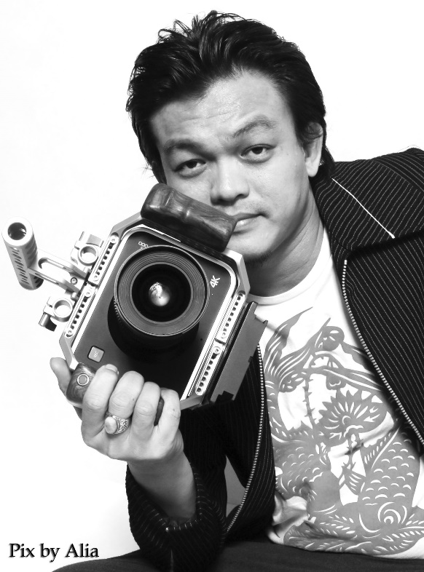
Ray Lee believe film can unite people, film can bring the world together. He not producing movie for money, he make money to produce movie.
Ray Lee, 44 years old Bachelor Degree in Creative Management is a film director, producer and music entrepreneur based in Kuala Lumpur, Malaysia.
Ray Lee used to work in Malaysia biggest English newspaper The Star Publication as a photojournalist since 1999 to 2008 and running a music school called Guitar Empire in Kuala Lumpur with 300 music students since 2010 before turning his childhood dream into a film maker. Ray Lee has produced and directed over 20 short films over the period of 5 years before produced his first Malay comedy television movie entitled ‘Bibikku Maduku’ (My Lover’s Servant) for Malaysia National TV Station RTM in 2014.
His first telemovie 'Bibikku Maduku' has been nominated as The Best TV Comedy by Anugerah Seri Angkasa (Universal Award) organized by Malaysia Multimedia and Communication Ministry in 2015 and watched by 1.2 million viewer’s through out Malaysia, Brunei & Singapore.
In 2017 he produced a TV show called ‘Bollywood Express’ for Tara HD, Astro Malaysia. This show had receives good response from the audience who love Bollywood song. It portrayed the local Malay artist singing Bollywood song in this show.
Ray Lee experience as a musician has lead him to produced more international music video from USA , Indonesia and China.
Together with Shenzen Hagpiel Piano Co Ltd. and his production company Hornbill Films, Ray produced and directed a music video shot in The Great Wall of China (listed in Malaysia Book of Record as the first Malaysia music video shot in The Great Wall of China) entitled ‘Getaran Jiwa’ featuring Malaysia piano maestro Dato Mokhzani Ismail.
In 2017 Ray has produced a music video in New York featuring American band Beat The System.
With their first single entitled ‘Be Your Own’, it has broadcast to over 50 countries in the world and listed in Vevo YouTube channel with 1.2 million viewers.
At the same year Ray Lee produced an Indonesian singer Tegar music video entitled ‘Kau Yang Terbaik’ with 3 million viewers in YouTube.
In 2017 Ray produced and directed his first feature movie , a Borneo Dayak language movie entitled ‘Dendam Gadang –Revenge of Gadang’ showcasing Borneo beautiful flora and fauna, native song as well as custom and culture of the local communities. This movie has won him Outstanding Contribution to Sarawak Film and Music Industries award.
In 2018 Ray has produced and directed his second feature , Malaysia first horror zombie movie entitled ‘Belaban Hidup -Zombie Infection’, a story about a secretive biological experiments lead by a mad scientist distorted into a complete dystopic state as Borneo is crippled by a zombie-like epidemic and will be schedule to screen on May 2020 throughout South east Asia cinema.
A holder of the Diploma in Film Making from Asia Metropolitan University and Bachelor Degree in Creative Industry Management from University Utara Malaysia (Northern University of Malaysia), Ray Lee has been actively involved in many Community Service Responsible activities such as teaching music and film making to the native people of Malaysia for free and sponsoring musical instrument to the charity homes throughout the Malaysia.
In Jan 2021 , Ray Lee has receives Malaysia most prestigious award, The Brand Laureate Leadership Award for his contribution towards building local film industry especially in grooming Malaysia indigenous people to become film directors, producers, actors. Ray Lee also giving free film making courses to all the indigenous people in the rural area. He would like to see more and more indigenous people to become film makers in the region. Ray Lee ambition is to start a movie in Hollywood someday, it is his childhood dream to start a movie in Los Angeles, USA.

