Film Industry Portfolio
Name: Prajwal Karpe
Working Areas: Actor and Director
DOB: 03-09-1991
For my Special Recognitions: https://filmfreeway.com/projects/1613391
Education: MTech in Computer Science
Work Experience(2014-Present)
1 | Anireekshitha | Kannada Short Film |  | Actor,Producer,Codirector,  Art Director
2 | Nimm Love Story | Kannada Short Film |  | Assistant Director
3 | Facebookgoanji Selfie | Tulu Short Film |  | Writer,Director,Producer
4 | Badalavane | Kannada Short Film | Was Nominated For Mangalore City level Short film Festival  Was Screened At Isiri Herbals Short Films Screenings | Director,DOP,Producer,  Dubbing Artist
5 | Mouna Mathadaga | Kannada Short Film | Won Best Film Award In Asian International Film Festival,2020  Official Selection For Lift Off Global Network Sessions,2020  Official Selection For Online Lockdown Short Film Festival West Bengal,2020 | Actor,Director,Writer,  Producer,Makeup Artist
6 | Om Sai Ram | Kannada Album Song |  | Actor,Director,Writer,  Producer
7 | Kabab | Hindi Short Film |  | Director
8 | Yenna | Tulu Promo Video |  | Writer and Director
9 | Shirastrana | Kannada Short Film | State Award For Best Dialogues | Assistant Director
10 | Kaligobbu | Tulu Short Film |  | Actor
11 | Mr. Bori | Tulu Feature Film |  | Actor,Captioner
12 | VIP’s Last Bench | Tulu Feature Film |  | Junior Artist
13 | Bhojaraaj Mbbs | Tulu Feature Film |  | Assistant Director and Juniour Artist
14 | Indiana Hospital | English Corporate Documentary |  | Actor
15 | Karbaar | English Mobile App Add |  | Executive Producer
16 | Aiwa Silks | Kannada Add |  | Dubbing Artist
17 | Day With A Star | YouTube Show |  | Anchor,writer,Director
18 | Imbu | Tulu Short Film |  | Actor

Special Recognitions and Awards
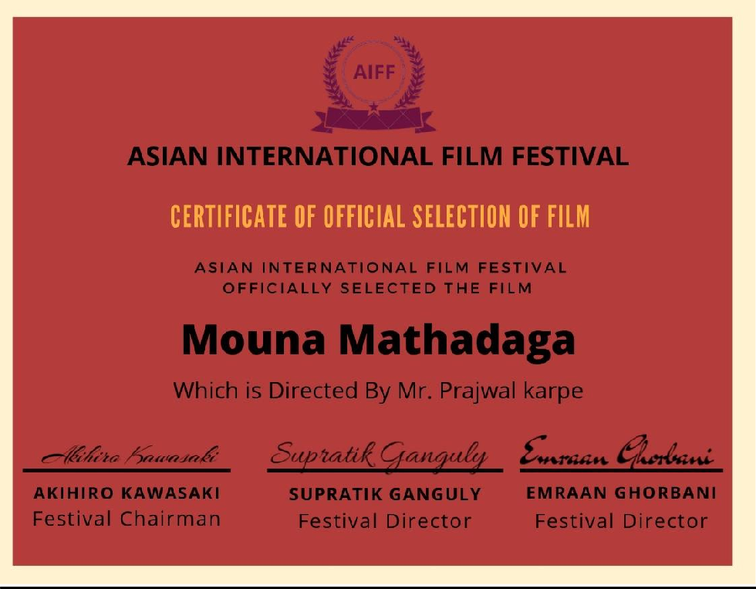
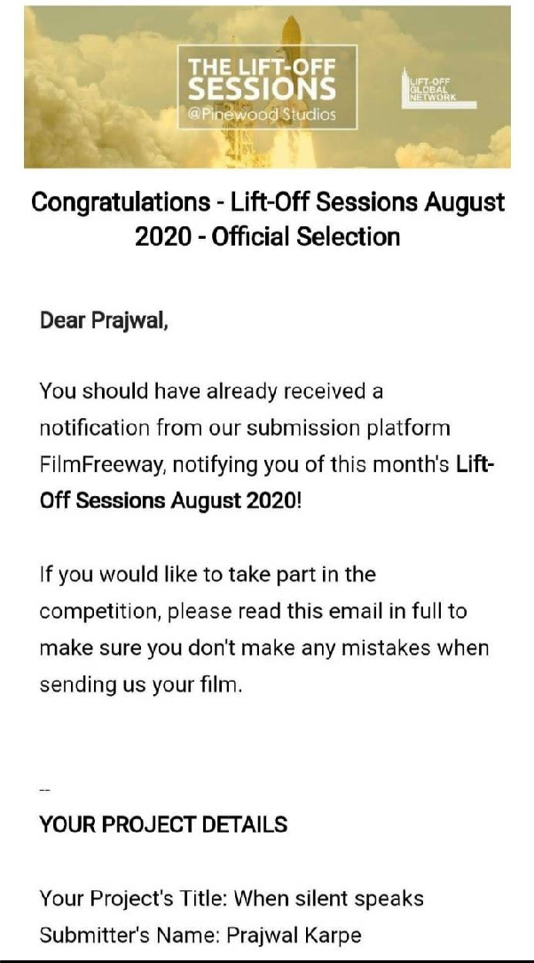
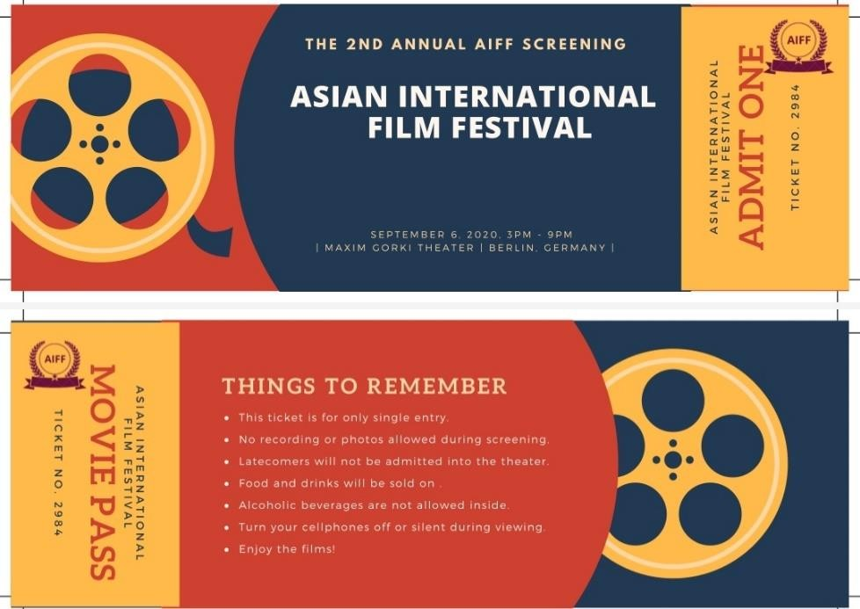

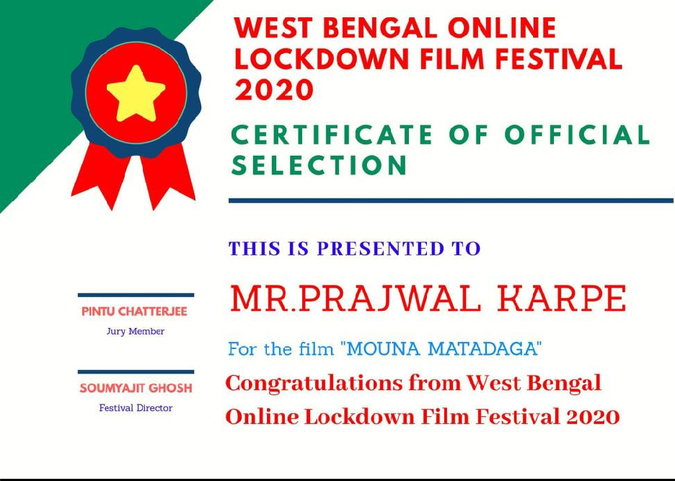

Certifications and Workshops in Filmmaking
