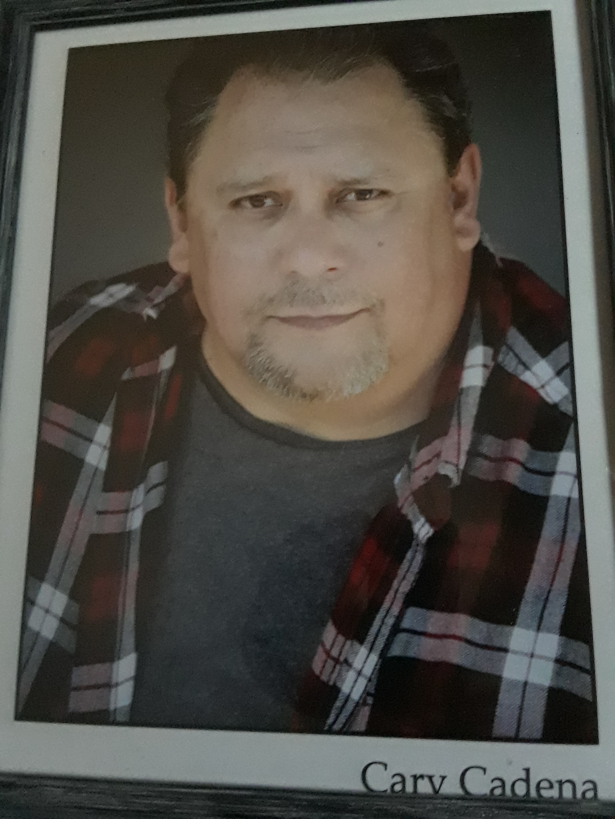
Alcario Cary Cadena

Height: 5’7

Weight: 225

Eyes: BRN

Hair: BRN
Formally with: The Blanco Talent Agency

SCREENWRITING:
- The Curandero/Healer (2018)
Texas Healer Don Pedrito Jaramillo Story
2. Dihigo: The Maestro (2018)
The Martin Dihigo Story
Greatest Baseball Player (GOAT)
3. A Season in Hell (2017)
WWII Normandy – All Americans 82nd Airborne
4. The Boy was a Hemingway Quote (2016)
Coming of age story
5. Canciones de la Gente
The Lydia Mendoza Story (2015/Musical)

ACTING/FILM:
Dreadtime Stories 2015, Chuck/Medical Examiner, (Feature)
STX Productions.

The Pupil 2016, Marcus/Angel, (Feature)
Alan Thornburg Productions

Amber’s Big Interview 2017, Supermanuel,
(Short.)

The Healer 2014 (Short)

The Sacrifice, Father Hernandez (Short.)

Redemption 2015, Heaven Doctor (Short)

The Perfect Game 2008, (Feature) Mexican Fan (Extra)

Blackland 2017, Director/Producer/Actor, Post Production

TV/Commercial:
Christmas Commercial 2015, Bell Ringer,
Las Palmas Mall CCTX.

Theater: Breakfast at Tiffany’s 2017, Joe Bell, North American Premiere, The Camille Theater Group

Annie, Mr. Bundles 2018, The Camille Theater Group

Training:
Acting 101, Texas A&I University (Rosenburg)
Acting in Front of a Camera, Texas A&M University
Editing and Screenwriting Workshop with Ken Rotkop

Education:
Master’s in Education 2014, The University of the Incarnate Word. Bachelor’s in History 2013, Texas A&M University. Associate Degree History 2012, Associate Degree in Liberal Arts 2012.

Skill/Training
Author, published a book, “The Curandero” 2019. Amazon Pub.
I have directed, been a cinematographer on several projects, shot a horror film, “Blackland” last summer.

