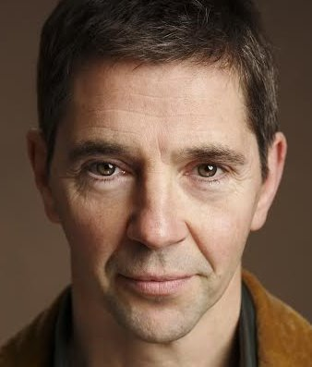
Tom Pigot
M: + 353 87 917 2380
E: tompigot@gmail.com

Height: 5’11”
Build: Medium
Hair: Brown/Grey
Eyes: Hazel

SHOWREEL: www.vimeo.com/184312873

THEATRE:
2018 Exiled Robert Hand Umbrella Theatre Co. Gerard Dalton
2017 Shores of Bohemia Grainger Umbrella Theatre Co. Celia de Freine
2011 Iphegenia in Aulis Herald Classic Stage Ireland Andy Hinds
2000 Bagging Groceries Vietnam GI Fritz Theatre SD Michael Skahill
2000 All Male Being Earnest Kurt Sweettooth Theatre SD Fred Tracey
1999 1940’s Radio Hour Wally San Diego College Mark Stevens

FILM:
2019 April 9th Aidan Tom Pigot
2018 Long Term Effects Mike Slattery Woods O’Rourke Barry Woods 2016 Detainment Jason Lee Twelve Media Vincent Lambe
2011 Greed Chris Attic Studio (Short) Daljit Gill

TV:
2017 Assassins Bill Somerville TV3 Keith Farrell

INDUSTRIAL:
Actor for California State Investigative Detective Training Programme.

TRAINING:
Gaiety School of Acting Advanced Page to Stage Clare Maguire
Abbey School of Music & Drama Acting for Camera Kathleen Warner Yeates
Rehearsal Room San Diego Film & TV Acting, Improv Carey Scott
Descano Studio San Diego Theatre Craft John Descano
Gaiety School of Acting Adult Short Course Drama
Gaiety School of Acting Shakespeare Workshop Liam Halligan

SPECIAL SKILLS:
Singing, rhythm guitar, cooking, motorcycles, tennis, basic French and Spanish, full clean driving licence.

