Blog August 26, 2019
Exciting news from Jeffry VanDavis, who lives in Germany, and who optioned my short play Fourth Quarter Pick-Up. Jeff’s film, All My Tomorrows won Best Director and Best Female Actor awards at the MegaFest Film Festival in Las Vegas, a gigantic festival. He also received three nominations at the Hollywood Dreams International Film Festival - for Best Director, Best Actress and Best Foreign Film. He just received notification that he won the Best Director award and his actress, Marisa Roman, won runner-up for Best Actress at the Dreams International Festival.
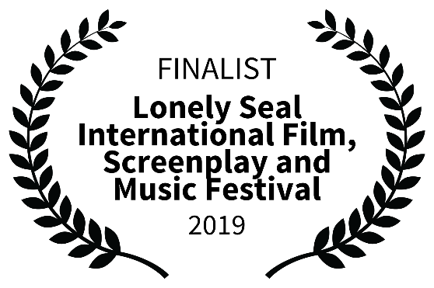
So excited to have the revised JoJo Mama and the Voodoo Queen as a finalist at the Lonely Seal Film and Music Festival outside of Boston in early October. The screenplay incorporates segments from the trilogy into the play and after many, many edits and rewriting to eliminate the over the top dialect, I think it works. Judy is proofing the revised stage play version as we speak? I mean write.
Fourth Quarter Pick-Up premiers as a short stage play, well not on a short stage but you get the meaning. The world-wide premier is at the Stranz Theater during the Tampa Bay Theatre Festival this coming Sunday, September 1st. The play will be directed by Pete Clapsis, a well-known actor/director in the Tampa Bay Area. Thank you, Pete and Owen, and the cast whom I have yet to meet, for launching the play.
Status of the novel that metamorphosized into a screenplay. Thanks to actors and friends, I was able to listen to the first reading of my new historical screenplay. It was great to hear the words and the characters as they came to life. I made several notes and received some very, very positive feedback as well as some good thoughts on how to make it an even better screenplay. It has been an exhaustive ten days with over 300 pages of editing by me and then another 100 pages by my wonderful proofreader, Judy Light, and then another 100 pages of editing to incorporate Judy’s proofing.
Thanks so much for reading this.

Take care.
LK

