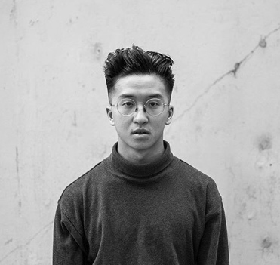 | ERIC CHEUNG  242 Sceptre Close NW  Calgary, AB T3L1Y3  403-554-6336 | erictzeloncheung@gmail.com
PERFORMANCE / CHOREOGRAPHY
TEDXTALK ECUAD (March 2019)  Vancouver, BC | Live VR performance/demonstration for MOR Robin Stethem talk on the future of VR in art.
PUSH OFF FESTIVAL (Feb 2019)  Vancouver, BC | 20-minute half way showing of “HAKO” by Ouro Collective
MUSEUM OF OTHER REALITIES (MOR) (Oct, Nov 2018)  Vancouver, BC | Two 5-minute live performance in Virtual reality VR in the MOR at their monthly parties.
CRUX (Nov 2017)  Vancouver, BC | 10-minute choreograph solo piece entitled, “without you, without me”.
SPARQ PRODUCTION. INC (Jun 2017)  Calgary, AB | choreographed a 10 - minute group popping performance at One –A Dance Spectacle 8th edition.
URBAN CARABET (December 2016)  Calgary, AB | 5-min duet popping performance
SHORT FILM
E_GO (Sept 2018)  Vancouver, BC | Commissioned by FORM Film Festival, “E_GO” was theatre premiere at the FORM Film Festival. Later premiered publicly on Booooooom.tv and featured on Nowness. Directed by Alan Sabir and Eric Cheung.
COMPETITION
1st 1v1 popping (Aug 2018)  Montreal, QC | Under Pressure XXII – Street dance Festival
3rd popping (Aug 2018)  Montreal, QC | Jack of all trades - JOAT
2nd 2V2 all-styles (May 2018)  Toronto, ON | Fired up - Street Dance All-Style Battle
1st popping (August 2017)  Vancouver, BC | Vancouver Street Dance Festival - VSDF
TEACHING / WORKSHOP
MOVEMENTALITY (January 2019)  Edmonton, AB | Popping workshop / private lesson for Movementality competitive team
UNIVERSE SOUL DANCE CO. (Dec 2018)  Calgary, AB | Popping & Groove workshop for Universe Soul dance groups A and B.
Illfx. CO (2017 – Present)  Calgary, AB | Popping instructor for Illfx’s dance groups.
culturally defined (2018 – Present)  Vancouver, BC | Popping instructor for Culturally defined dance groups levels 1.5 and 2.0
TRAINING
OURO COLLECTIVE - Vancouver, bC (2018- present)
Summer Dance Forever - Amsterdam, Holland (2016)
Change the Game 2015 - Calgary, AB, Canada (2015)

