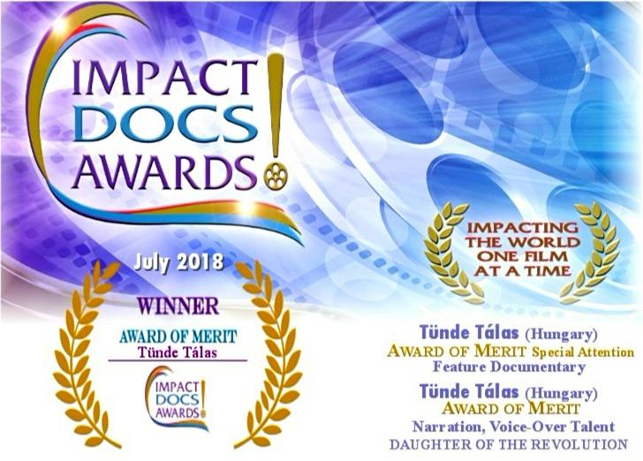
FOR IMMEDIATE RELEASE
Contact: Peter Hargitai
hargitai@fiu.edu
305-801-6020
https://filmfreeway.com/peterhargitai

Tünde Tálas Picks Up More
Awards From Impact DOCS
Awards Competition

La Jolla, California. 26 July 2018 – Hungarian director Tünde Tálas wins again in California. After picking up awards at the Hollywood International Independent Documentary Film Festival in March of this year, Tünde Tálas of Új Budapest Filmstúdió has won two more prestigious prizes – Award of Merit (Special Mention) in the “Feature” category and another Award of Merit in the “Narration-Voice Over Talent” category from The Impact DOCS Awards Competition. The awards were given for her documentary DAUGHTER OF THE REVOLUTION which features a compelling narrative, charged with authentically original language, and a multilevel “story within a story” conveyed through an original mix of narrative, animation and historical footage. The film’s message is about finding humanity even in inhumanity and ultimately making the world more humane. The documentary honors the schoolgirl heroines of 1956 Budapest and the author of the novel on which the documentary is based. Tünde Tálas’s awards affirm her as a filmmaker of refreshingly original talent, and honor her and the unheralded young women who are so much a part of her documentary, the ones who fought and died on the streets of Budapest. Her film is a document and a memorial of all the oppressed who paid with their lives for a fleeting glimmer of freedom.

Impact DOCS recognizes documentary filmmakers who demonstrate exceptional achievement in craft and creativity, and those who produce artistic work that contributes to profound social change. Documentaries were received from 30 countries, including veteran award winning filmmakers and fresh new talent. Entries were judged by highly qualified and award winning professionals in the film and television industry from around the world. In winning an Impact DOCS award, Tünde Tálas joins the ranks of other high-profile winners of this internationally respected award including the Oscar winning director Louie Psihoyos for his 2016 Best of Show – Racing Extinction, Oscar winner Yael Melamede for (Dis)Honesty – The Truth About Lies, and Emmy Award winner Gerald Rafshoon for Endless Corridors narrated by Oscar winner Jeremy Irons, and many more.

Impact DOCS Awards is in its second year and is the newest member of the Global Film Awards (GFA) family of competitions who have been hosting competitions for 14 years. As one of the original trend-setting digital online competitions, GFA set the standard for this exciting new breed of film competitions.. GFA’s Accolade Competition was named by Movie Magazine “…as one of the top 25 festivals worth the entry fee”. It is truly international in scope offering filmmakers from large powerhouses like Disney, The Weinstein Company, Discovery and Ridley Scott all the way to first time filmmakers and students, the opportunity to receive valuable feedback from an impartial judging panel comprised by highly qualified and award winning professionals in the industry. Often the first stop on the festival circuit, GFA award winners have gone on to win Oscars like the short doc “The Lady in Number Six” and “Mr Hublot” as well as countless Emmys, Tellys and more. Information about the Impact DOCS Awards and a complete list of winners can be found at www.ImpactDocsAwards.com

