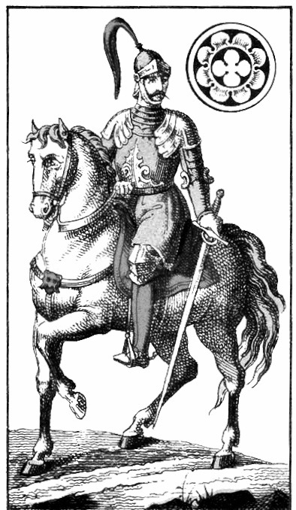 | Morgan Miller  417 Summer Road  Davis, West Virginia  26260  cell: 304 629 3556  SirReelPictures@Gmail.com | BIOGRAPHY  Born in West Virginia, I grew up on cinema and graduated from Montana State University with a bachelors degree in Film and Photography (2015). My first love was Disney’s classic Jungle Book (1967) but it was not until he saw The Evil Dead (1981) that I took aspirations on becoming a filmmaker.  Since completeing my studies, I have worked as a freelance videographer (making documentaries, music videos and my own short films), writer, & teaching assistant to further my knowledge on filmmaking. I also own and operate a small business in Davis, West Virginia – Trailhead Coffeeshop.  EXPERIENCE  Founder, SIR REEL PICTURES  JAN. 2015 - PRESENT  During my final year at university, I set up my own production company to work solely on my own endeavors. The main spark for this was my Senior Thesis project being rejected. It made me take matters into my own hands and be a fully functional, independent filmmaker who doesn’t take no for an answer.  Accomplishments  - Premiered my music video entitled, “Free Hand” at the 2015 G.O.R.G.G. (Global On Reflection Giant Gathering) event in Montreal, Canada.  - Awarded Best West Virginia Film for the short film, “Charles the Tree”, at the West Virginia Mountaineer Short Film Festival on April 14, 2018.  - Became a certified Production Accountant thanks to workshop hosted by John Gaskin.  Filmmaker / Editor, HANDS AROUND THE WORLD  Auckland – Christchurch, NEW ZEALAND – NOV. 2017  - Commisioned by Hands Around the World, an Australian non-profit organization, to complete a sovereignty documentary for the Maori people of New Zealand. [currently in post-production].  Camera Operator, MAKE WEIRD MUSIC  Albuquerque, NM – OCT. 2017  - Provided B-roll footage of Closeups and Extreme Closeups for an in-depth interview between musicians; namely Gary Green, Kerry Minnear, & Malcolm Mortimore of Gentle Giant and Mike Keneally of Frank Zappa.  Filmmaker / Editor, SASHAPURE Beauty  Lima & Tarapoto, PERU – SEPT. 2017  - Part of a three man production team into Amazonian Rainforest to capture footage showcasing the Sacha Inchi plant for a hair beauty company.  - Worked with several Indigenous communities (Pinto Recodo & Alfonso Ugarte) in the San Martin region in Peru.  - Completed FAA part 107 course for Unmanned Aircraft (Drone)  - Responsible for pre-production storyboards and post-production editing and media deliverables.  Videographer / Editor, MANKIND  Brighton, UNITED KINGDOM – MAY 2016  - Completed promotional videos consisting of interviews and B-roll footage to highlight a locally written and performed play entitled “Groomed” for the 2016 Brighton Fringe Festival.  1st Assistant Camera, ROOSTER RECORDING STUDIO  London, UNITED KINGDOM – MAY – APRIL 2016  - Captured B Camera footage of musicians recording songs for Angelika’s Live Indie Sessions.  Teaching Assistant, MONTANA STATE UNIVERSITY  Bozeman and Browning, MT – JAN. – MAY 2015  - Volunteered to teach the various modes of documentaries to underserved Blackfeet Community College students  - Lesson plans included fundamental filmmaking techniques in lighting, editing, & camera set-ups.  Utilities, ROOT SPORTS  Bozeman, MT – NOV. 2013/2014  set up cameras, ran slack, and wrapped cable for University football games.  EDUCATION  Montana State University  Bachelor of Arts - FILM AND PHOTOGRAPHY — 2012 - 2015  Graduated with overall 3.0 GPA. Specialized in Directing, Cinematography, and Editing, with other training in: grip and electric (including best boy), interviewing, screenwriting, storyboarding, acting, and also producing.  Film school was a great step for me to get a handle on technicalities of the artform and come away with one conceptual idea - the first rule of art is there are no rules.  SKILLS  - Ideas - as a creative person, it is necessary to think outside the box and question “standards”. Is it real? Is it interesting?  - Collaboration - I do not make films where it is solely about myself. I create a team or a family rather, that I feel comfortable with and we all make decisions collectively.  - Taste - I am very fortunate to know not what I always want but to know what I always don’t want. Filmmaking is the active process of figuring this out. I know what I like and I like what I know.  REFERENCES  Lucia Ricciardelli, Associate Professor at M.S.U.  Luciaricciardelli@gmail.com  James B. Joyce, Associate Professor at M.S.U.  James.joyce1@montana.edu  Lynne Sealotus Edmundson, Hands Around the World  Sealotus1959@hotmail.com  Anthony Garone, Make Weird Music  Anthony@MakeWeirdMusic.com  Jim Travagline, Owner of SASHAPURE Beauty  Jim.Travagline@redlodgebeauty.com  Angelika Miller, Angelika’s Live Indie Sessions  AngelikaMiller7@gmail.com  Wayne Moss, Root Sports coordinator  Wmoss@rootsportsnw.com

